Vinay Kumar K
SAP FICO Practitioner
📞 6303986100 ✉️ Vinaykumar75477@gmail.com 📍 #3/646 Adhra mess pg, JP Nagar, Bengaluru 560056
PROFILE  Motivated and adaptable professional with strong problem-solving abilities, a commitment to learning, and focus on delivering reliable results.  SKILLS  - SAP FICO  - S/4 HANA  - ERP Software familiarity  - Typing skills  CERTIFICATIONS  -   -   -   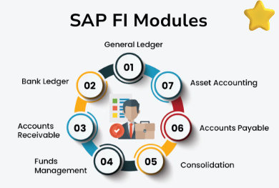 | OBJECTIVE  To secure a position in a growth-oriented organisation where I can apply my abilities, develop new skills and contribute effectively to team goals while progressing in my career.  EDUCATION  B. Com - S.P.V.M Degree College, Gorantla  PROJECTS  - Completed internship during degree on Google Transcription at RND Softtech, Coimbatore.  - Worked on transcription accuracy improvements and data formatting for client deliverables.  - Collaborated with team to ensure timely completion and quality standards.  

